Preparing Images for the KCPA Annual Exhibition
The KCPA are providing these “Helpful hints and tips to assist you with your exhibition entry. However, we can in no way be held accountable for any views or comments that a judge may make about the submitted image”

- Create 2 folder’s for the images you wish to enter into the exhibition, on your desktop. Make 1 for your PDI entry, and 1 for your Print entry. You are allowed up to 30 images in each, but do check Conditions for full details.
- Edit your image.
- Preserve your master copy as you normally would, these notes assume that Photoshop is used, but if you are using Paint Shop Pro or another application then save in your normal format for that. DON’T SAVE YOUR MASTER AS A JPEG !
- Save it as a normal Photoshop file so that you can go back to it later if necessary.
- Use Image->Image Size… to reduce the size of the image to the smaller limit size required for competition entry according to the proportions of your image, e.g. a letterbox-shaped image would typically be a maximum of 1600 pixels wide, or a portrait-shaped image would be a maximum of 1200 pixels high. Set Resolution to 300, we are asking for high resolution for printing of the catalogue.

Landscape Orientation example.
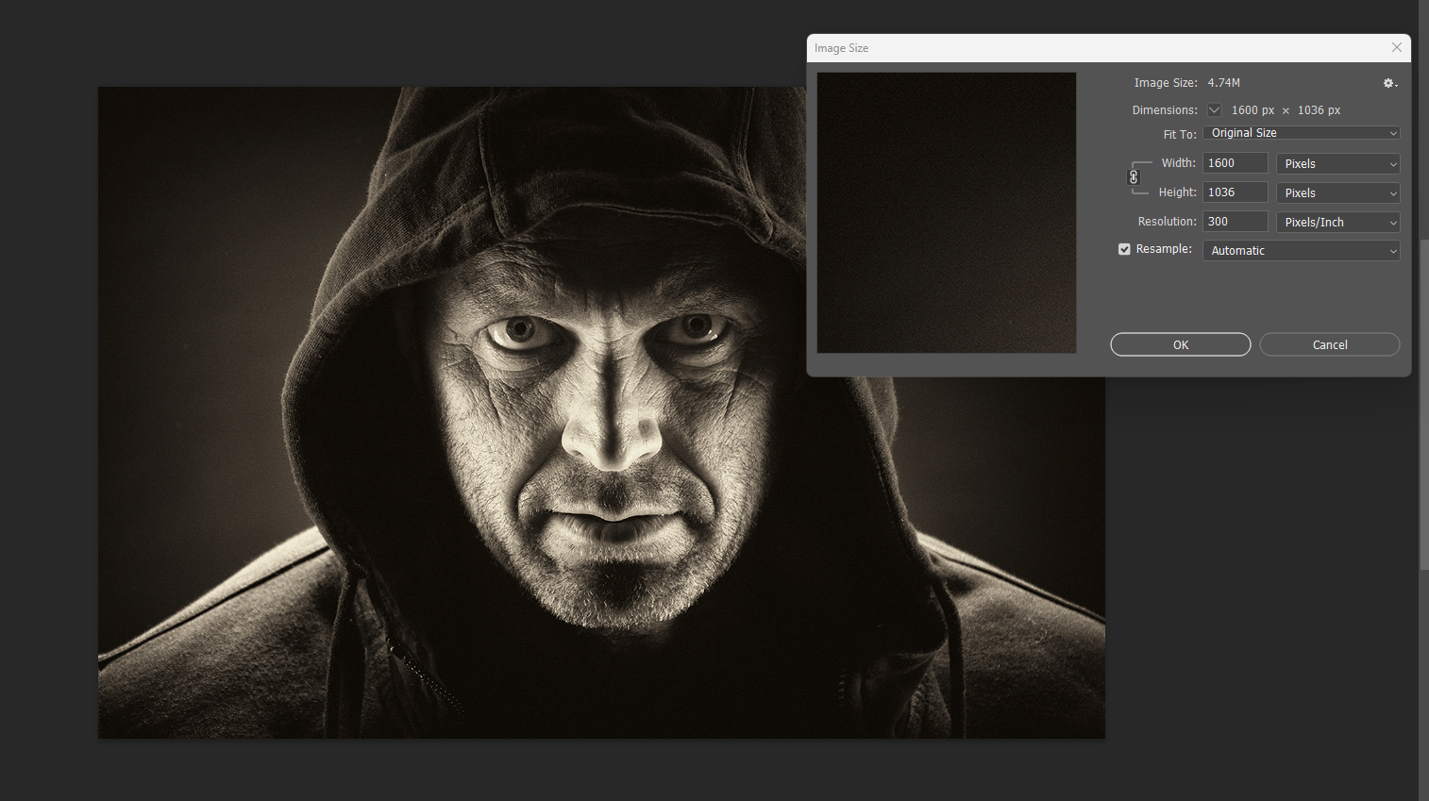

- Zoom in to 100% or even 200% so that you can see how your image will project.
- Please do not add any unnecessary borders to your images. Black borders serve no purpose for digital projection, while white borders can distract the eye from the image. A thin stroke around the image is acceptable.
- Use the - Edit->Convert to Profile function to make the colours in your image into sRGB format so they show the up as the ‘correct’ colours on projectors and monitors.

Portrait Orientation example.
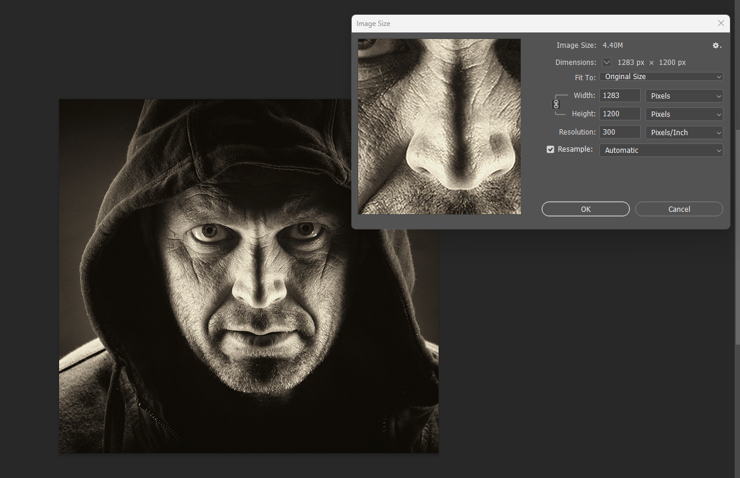
- GO TO File>Save As Copy You can make sure your File Name is correct at this stage and save it to your images folder for the Exhibition.

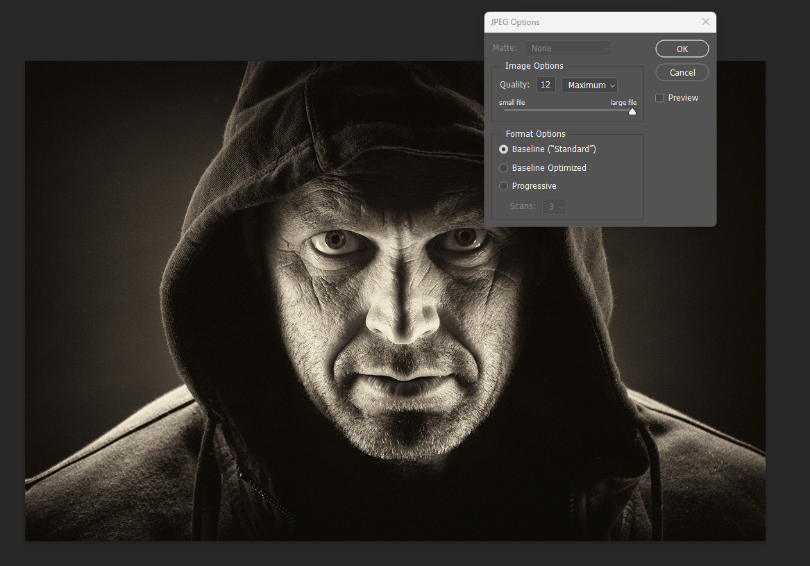
- This is the procedure for your PDI entry.
- When all your images are resized, checked and saved to your folders you are ready to entry them into the exhibition.

- You will need to complete the entry form, if entering prints put 1 copy of this in with your prints.
- For PDI entries fill in the entry form and email it to competitions@kcpa.co.uk and you’re your images via wetransfer to this email address or via DVD, whichever you find easier.
- Once you are happy with your entry, you will need to pay for your entry you can do this via PayPal, or cheque payable to KCPA
- For prints only or prints and PDI’s put the cheque in with your prints.
- For PDI only send cheque payable to KCPA to 6 Cook Close, Lordswood, Chatham, Kent. Me5 8LU.
- For your Print Entry you remember to order your prints in the box or packaging in the same order as on the entry form
- Don’t forget to download and print the labels to attach to the back of your images
- Please do not wrap your print entries individually in cellophane!
- Deliver your prints, payment (if paying by cheque) entry form to one of the drop of points.

The KCPA Wish all those that enter success with their images and many thanks for entering this year’s Exhibition.

