

Have you been thinking about becoming a Judge?

A quick guide

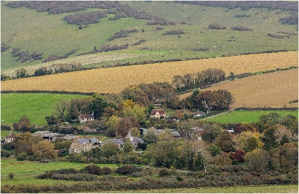





Judges guide version 4 - July 2026

What skills do I need?
A love of photography and the ability to talk to an audience.
Do I need any photographic qualifications
No, being a KCPA club member for at least 2 years, active within the club and regularly entering competitions is all that is required.
What training will I get?
Training will be provided by experienced KCPA judges, both by Zoom and in person.
Can I have a mentor?
Yes, if you wish, by arrangement with an experienced judge.
How soon can I start judging?
Once you have successfully participated in the Zoom introductory session and one of the judging roadshows. A recommendation from your club committee is also required.
What geographical area can I cover?
Entirely your choice.
Can I claim expenses?
Yes, currently up to 55p per mile.
Can I get additional support / training in respect of judging specialist genres?
Yes, we have judges who cover a wide range of genres who can help.

Still interested?
We hope this information has been useful, if having a try at judging now appeals to you, please inform the KCPA Judges’ Panel Chair
Andy Smith LRPS CPAGB at:-
Andy24tse@gmail.com
We can then have a chat and talk through the process.
What happens after that?
Zoom introduction to judging sessions are being held, please keep an eye on the KCPA website for further details regarding dates.
And after this, if you feel this could be for you, why not attend…
A judging roadshow, where your judging skills can be observed in person. These are going to be held around the county. Details regarding dates and venues will be publicised on the KCPA website.
Judging is rewarding, fun, inspirational and the opportunity to give guidance, help and advice to fellow camera club members
We hope that this has inspired you to start your judging career today.

Thank you for your interest, with best wishes from the KCPA

The KCPA Judges’ Panel
The purpose of the Panel:-
The Judges’ Panel is the body created and empowered by the KCPA Committee to oversee their policy for judges and judging.
The membership is normally confirmed / modified, as required, at each AGM although interim changes can be made by the KCPA Committee if desired necessary.
The current Panel Membership is:-
Andy Smith LRPS CPAGB (Chair)
Steve Carroll FRPS DPAGB
Pat Couder CPAGB BPE1 QPSA
Paul Parkinson ARPS CPAGB BPE3
Helen Shore ARPS DPAGB BPE3
Clive Tanner FRPS MPAGB APAGB

Current initiatives:-

To encourage more KCPA Club members to become judges, through publicising the key requirements and benefits of being a judge.

To run a series of Zoom
“Judging Appreciation” sessions

To run “Introduction to Judging roadshows” where prospective judges can develop face to face judging experience.

“Judging Appreciation” Zoom sessions

These sessions will be held on the following dates:-

Dates will be advertised on the KCPA website

“Introduction to Judging” Roadshows

It is proposed that “Introduction to Judging” Roadshows (dependant on the geographical locations of potential judges) will be held at suitable locations during 2026

Dates and locations will be advertised on the KCPA website

If you are interested or have any questions please contact Andy Smith on

Andy24tse@gmail.com

Thank you for your interest
Andy Smith, Judges Panel Chair

Notes

