DIAMOND JUBILEE 2019
INSTRUCTIONS for sending images.
Images can be sent via –
Wetransfer.com to competitions@kcpa.co.uk
Email competitions@kcpa.co.uk
DVD to Tracy Hughes, 6 Cook Close, Lordswood, Chatham. Kent ME5 8LU
Memory stick Address as above.
Should you require any help with sending the images or require any more information please contact Tracy Hughes via competitions@kcpa.co.uk or telephone 01634 303540
____________________________________________________________________________
If you wish to send the images via wetransfer please follow the instructions below:
https://wetransfer.com/
As you will see from the image below once you have clicked on the website you will get a screen similar to the one below.
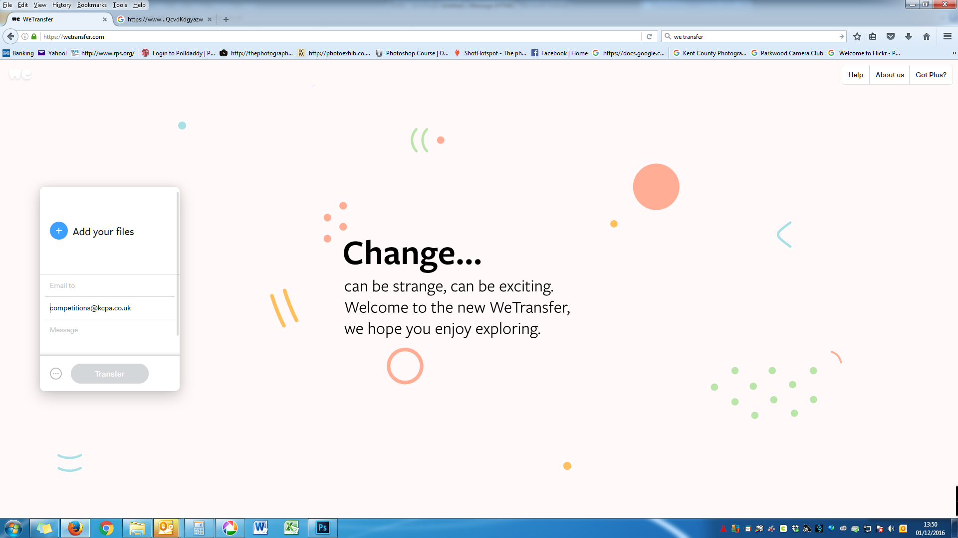
On the left hand side of the screen you will see there is an “Add your files” button, you will need to click on this in order to be able to add your club’s competition entries.
Please ensure your images are sized correctly, and the titles are in the correct format.
http://www.kcpa.co.uk/resolution-sizing-and-colour-space/
TITLE by photographer Name.jpg
For example LANDSCAPE by Garter Carter. Jpg
Once you click on the add files option you will be able to locate your clubs competition images, and select them for upload.
The screen will then confirm to you on the left hand side how many images you have added, this should be 9 (8 images plus the entry form).
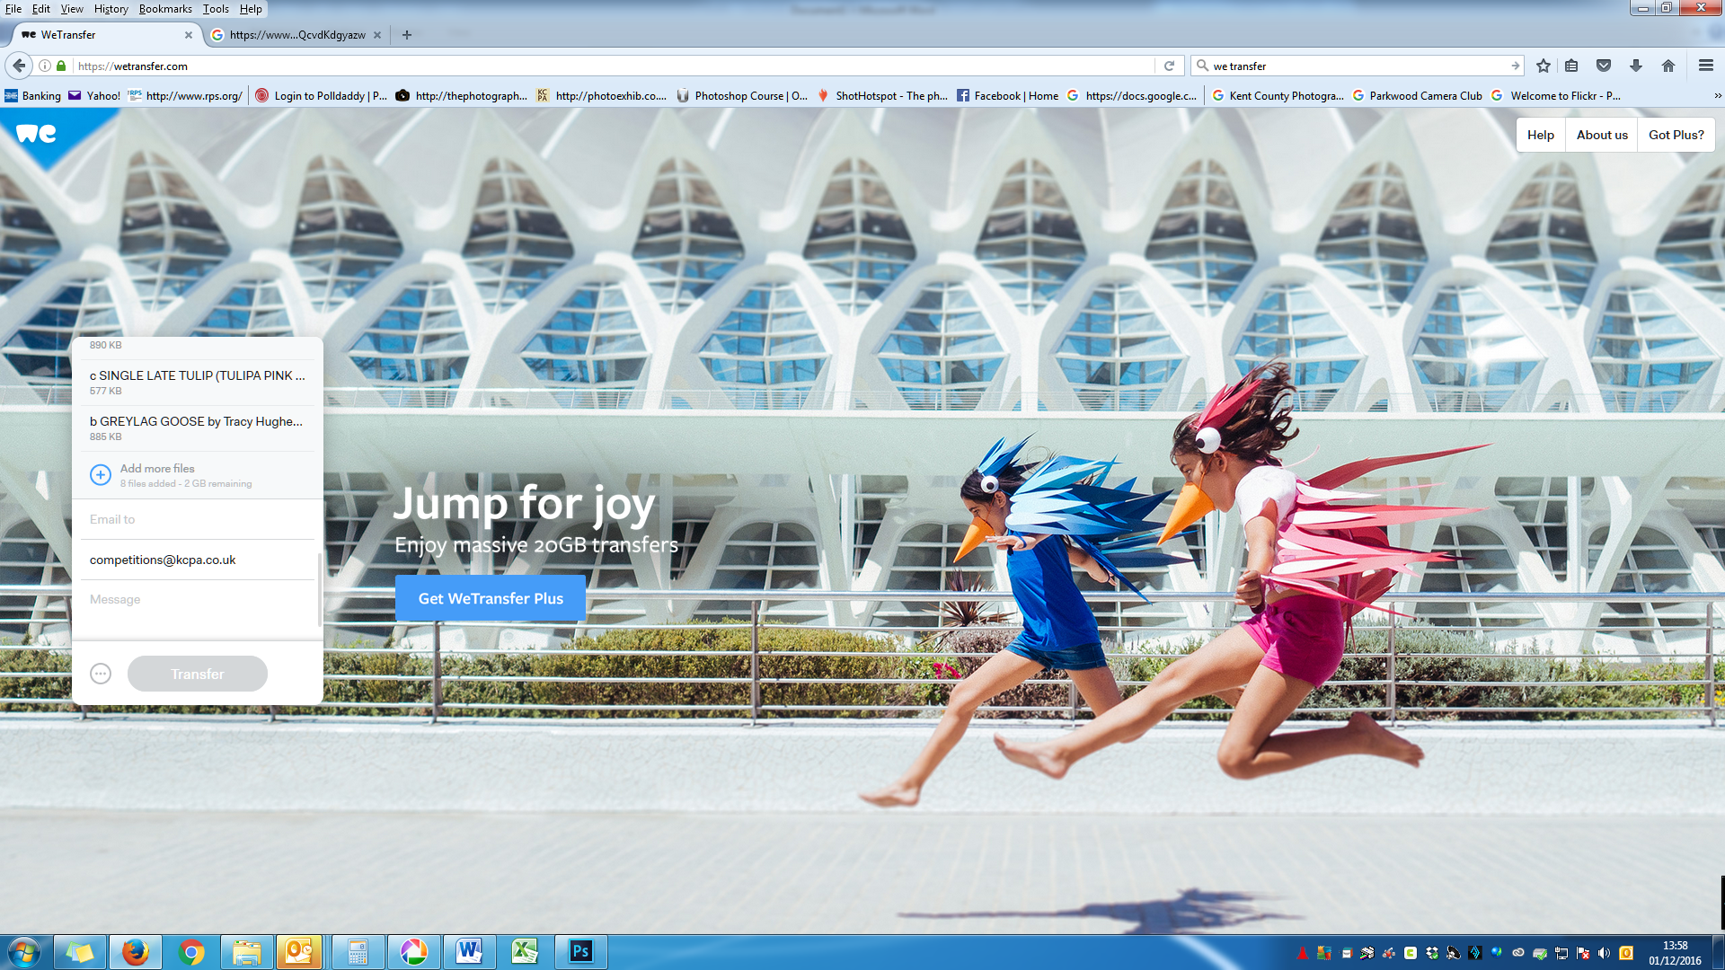
You will need to amend to email addresses to show your own as the sender, and competitions@kcpa.co.uk as the recipient.
In the message box, type in your club name please.
Click on transfer button. During the process the screen will tell you the progress of the transfer.
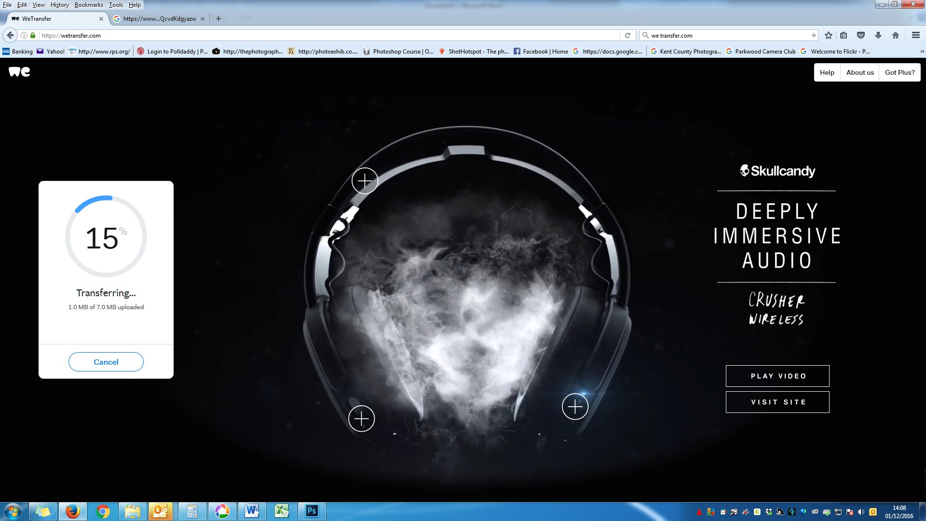
After your files have been transferred and sent to the recipients email address, you will see this screen.
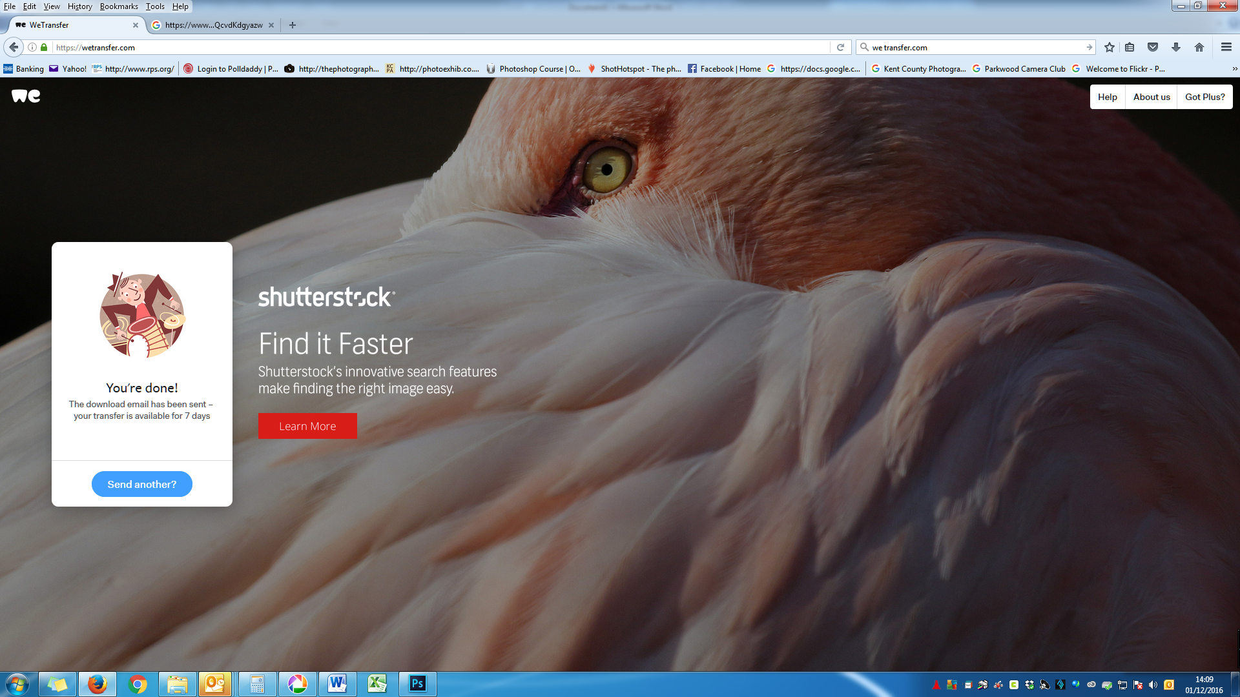
The person receiving the email will be notified of images waiting to be downloaded, and once action has been taken the sender will receive an email saying “Thanks for using WeTransfer - file sent to competitions@kcpa.co.uk”

