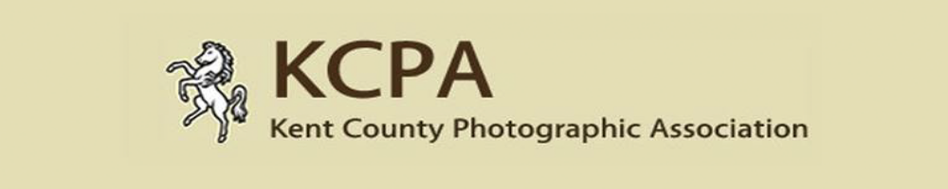
Diamond Jubilee 2018
Entry Form; Opening date 1st December 2017
Closing Date – 14th January 2018
Club Information
Name of Club –
Name of Contact -
Address (including postcode)
Telephone Number (including area code) –
E-mail Address -

Image Details – (Complete in BLOCK CAPITALS)
 | PDI Title (List in A-Z order) | Full Name of Photographer  Max 2 image’s per photographer | Distinction held (Max 3) | Score | Award | *Permission given  (Y or N)
Club Total Score
* NB In relation to the permission given column, we understand that individuals may prefer not to have their images displayed on website so they now have the option to choose.

Entry Instructions.
- Complete 1 copy of this Entry Form. All text must be in BLOCK CAPITALS & in A-Z title order.
- Email form to competitions@kcpa.co.uk
- Payment of £30.00 to be paid via cheque made payable to KCPA and sent to 6 Cook Close Lordswood, Chatham, Kent ME5 8LU or paid online via www.kcpa.co.uk using PayPal (Full instructions on website).
- Entry Form and images to be sent via https://wetransfer.com/ to competitions@kcpa.co.uk
Or images can be sent via CD or USB Stick via address above.
All forms, images and payments must be received before close of 14th January 2018

If you have any questions relating to the competition please email
Tracy Hughes via competitions@kcpa.co.uk or telephone 01634 303540
The full conditions of entry are shown on the KCPA website.

