KCPA Exhibition 2018
INSTRUCTIONS for PDI exhibition images.
This year we will be asking club memebrs who are entering the PDI section of the KCPA exhibition to submit either images either via DVD or USB or by using a free online service called wetransfer.com
If submitting images via DVD
Please ensure your images are added to a folder on the disk the folder should be titled with your name.
If submitting images via USB
Please ensure your images are added to the stick and your name displayed on the usb stick
If submitting images via we transfer , Please follow the instruction below
https://wetransfer.com/
As you will see from the image below once you have clicked on the website you will get a screen similar to the one below.
On the left hand side of the screen you will see there is an “Add your files” button, you will need to click on this in order to be able to add your club’s competition entries.
Please ensure your images are sized correctly, and the titles are in the correct format.
http://www.kcpa.co.uk/resolution-sizing-and-colour-space/
TITLE by photographer Name.jpg
For example SEAFORD LANDSCAPE by Garter Carter. Jpg
Once you click on the add files option you will be able to locate your exhibition images, and select them for upload.
The screen will then confirm to you on the left hand side how many images you have added, this should be the same as stated on PDI section of your entry form.
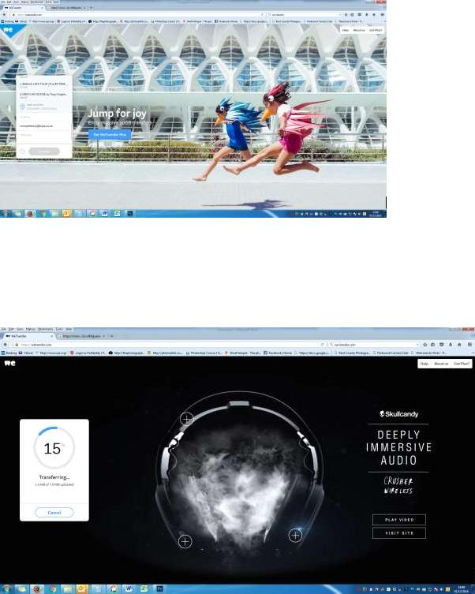
You will need to amend to email addresses to show your own as the sender, and competitions@kcpa.co.uk as the recipient.
In the message box, type in your name please.
Click on transfer button. During the process the screen will tell you the progress of the transfer.
After your files have been transferred and sent to the recipients email address, you will see this screen.
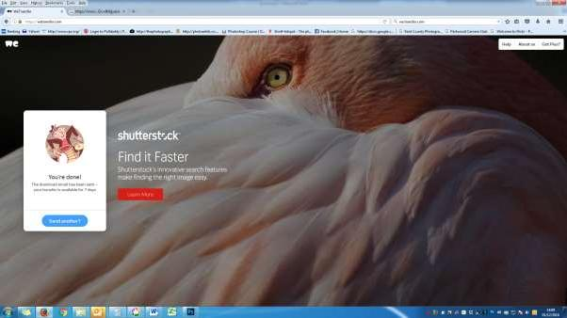
The person receiving the email will be notified of images waiting to be downloaded, and once action has been taken the sender will receive an email saying “Thanks for using WeTransfer - file sent to competitions@kcpa.co.uk”
Should you require any help with sending the images or require any more information please contact Tracy Hughes via competitions@kcpa.co.uk or telephone 01634 303540

