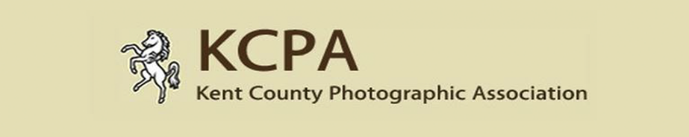KCPA Print & PDI Exhibition 2020
Entry Form; Closing Date – 10th March 2020

Name of Photographer -
Distinction (Max 3) -
Name of Club -
Address (including postcode) -
Telephone Number (including area code) –
E-mail Address -

Please state below how many Print and PDI images you are entering & how you will be paying for your entry, by filling in the amount you are paying in the correct box below.

If entering the print section as well as the PDI section, please enclose Cheque with prints made payable to KCPA; for PDI’s alone please send cheque to 6 Cook Close, Lordswood, Chatham, Kent. ME5 8LU. If paying via PayPal follow instructions on website.

Alternatively speak to your club coordinator who may collect all the payments together and send one combined payment to the KCPA for their members’ entries

Cost & paying for your entry - £6 for 1st 3 images in each section, then £1.25 each additional image (up to 30 images max each section) Max £39.75 per section.

How Paying: Please tick box
PRINT | PDI | CHEQUE | PAYPAL

Drop off point selected (Circle one chosen) 1 2 3 4

PRINT SECTION
Image Details – (Complete in BLOCK CAPITALS)
 | TITLE OF IMAGE (A – Z Order please) | CATAGORY | SCORE | * Permission Y / N
1
2
3
4
5
6
7
8
9
10
11
12
13
14

15
16
17
18
19
20
21
22
23
24
25
26
27
28
29

30
* NB In relation to the permission given column, we understand that individuals may prefer not to have their images displayed via kcpa.co.uk so they now have the option to choose.

Categories – Nature, Colour Pictorial, Mono Pictorial, Portraiture, Record and Creative.

Entry Instructions - Prints
1. Affix Entry Labels to rear of prints, top right hand side. (See labels sheet)
2. Complete this Entry Form. All text must be in BLOCK CAPITALS.
3. Place 1 completed form in your print box & email 1 completed form to competitions@kcpa.co.uk
4. Include with your prints competition entry fee SEE ABOVE & WEBSITE FOR FURTHER DETAILS
5. Prints, Entry Form and payment (as described above) to be sent or delivered to one of the drop off points.
6. All prints and entry forms must be received before close of 8th March 2019.

PDI SECTION

Image Details – (Complete in BLOCK CAPITALS)
 | TITLE OF IMAGE (A – Z Order please) | CATAGORY | SCORE | * Permission Y / N
1
2
3
4
5
6
7
8
9
10
11
12
13
14

15
16
17
18
19
20
21
22
23
24
25
26
27
28
29

30
* NB In relation to the permission given column, we understand that individuals may prefer not to have their images displayed via kcpa.co.uk so they now have the option to choose.

Categories – Nature, Colour Pictorial, Mono Pictorial, Portraiture, Record and Creative

Entry Instructions - PDI
- Complete the entry form and include it in with your we transfer file to competitions@kcpa.co.uk or email form to this email address and include it with the DVD or usb stick if you are sending entries via post to the address on the website.
2. Full details of how to use this can be found on the KCPA website

If you have any questions relating to the competition please email Tracy Hughes via competitions@kcpa.co.uk or telephone 01634 303540 or 07966298607. Full conditions of entry are shown on the KCPA website.

