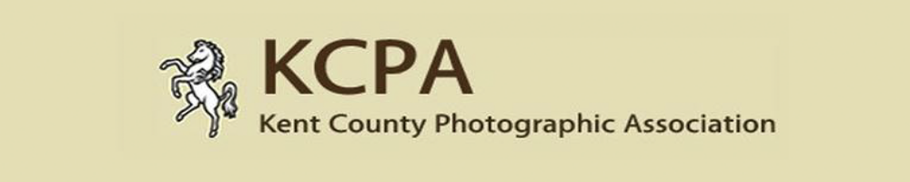
KCPA Print & PDI Exhibition 2018
Entry Form; Closing Date – 8th March 2018
Name of Photographer -
Distinction (Max 3) -
Name of Club -
Address (including postcode) -
Telephone Number (including area code) –
E-mail Address -

Please state below how many Print and PDI images you are entering (Max 30 per section).

Please state how you will be paying for your entry, by filling in the amount you are paying in the correct box below.

If entering the print section as well as the PDI section, please enclose Cheque with prints made payable to KCPA; for PDI’s alone please send cheque to 6 Cook Close, Lordswood, Chatham, Kent. ME5 8LU. If paying via PayPal follow instructions on website.

Alternatively speak to your club coordinator who may collect all the payments together and send one combined payment to the KCPA for their members’ entries

Cost & paying for your entry - £1 per image entered (up to 30 images max each section) Max £60.

PRINT | PDI | CHEQUE | PAYPAL

Drop off point selected (Circle one chosen) 1 2 3 4

PRINT SECTION

Image Details – (Complete in BLOCK CAPITALS)

 | TITLE OF IMAGE (A-Z Order please) | CATEGORY |  | SCORE | Permission given?  Y or N
1
2
3
4
5
6
7
8
9
10
11
12
13
14

15
16
17
18
19
20
21
22
23
24
25
26
27
28

29
30
* NB In relation to the permission given column, we understand that individuals may prefer not to have their images displayed via kcpa.co.uk so they now have the option to choose.

Entry Instructions - Prints
1. Affix Entry Labels to rear of prints, top right hand side. (See labels sheet)
2. Complete this Entry Form. All text must be in BLOCK CAPITALS.
3. Place 1 completed form in your print box,
4. Include with your prints competition entry fee SEE ABOVE & WEBSITE FOR FURTHER DETAILS
5. Send a copy of your entry form to competitions@kcpa.co.uk
6 Prints, Entry Form and payment (as described above) to be sent or delivered to
1 of the drop off points.

All prints and entry forms must be received before close of 8th March 2018.

PDI SECTION

Image Details – (Complete in BLOCK CAPITALS)

 | TITLE OF IMAGE (A-Z Order please) | CATEGORY |  | SCORE | Permission given?  Y or N
1
2
3
4
5
6
7
8
9
10
11
12
13
14

15
16
17
18
19
20
21
22
23
24
25
26
27
28
29
30

* NB In relation to the permission given column, we understand that individuals may prefer not to have their images displayed via kcpa.co.uk so they now have the option to choose.

Entry Instructions - PDI
- Complete the entry form and include it in with your we transfer file or include it with the DVD or usb stick if you are sending entries this way.
- In addition to the above, email form to competitions@kcpa.co.uk

Full details of how to use this can be found on the KCPA website

